Group 10

Author: 叶菁菁

Software Specifications

Pocker Game

Table of Contents

System Architecture 2

Software Specifications 2

S1: playerUI implementation 2

## System Architecture

The system architecture is shown below: 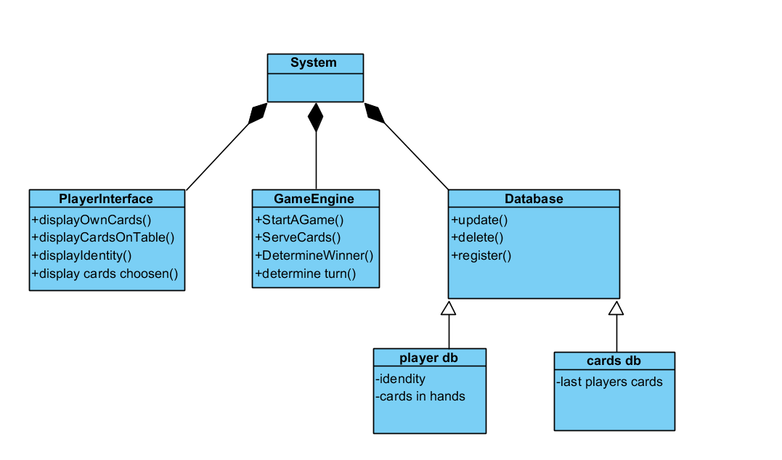

## Software Specifications

### S1: playerUI

#### S1.1: start the game

S1.1.1 there is a number record how many people have press startbutton

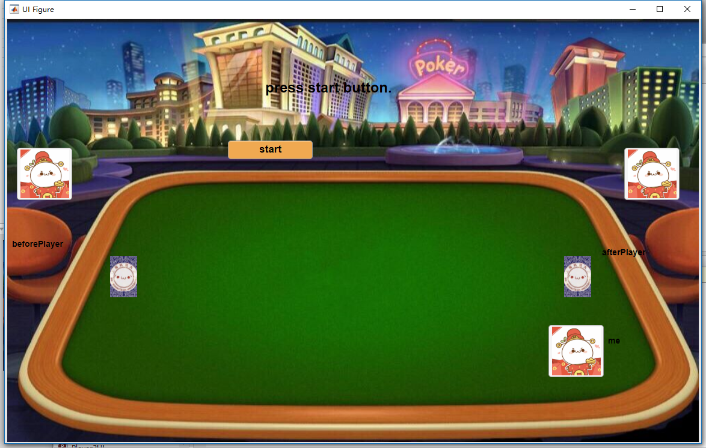

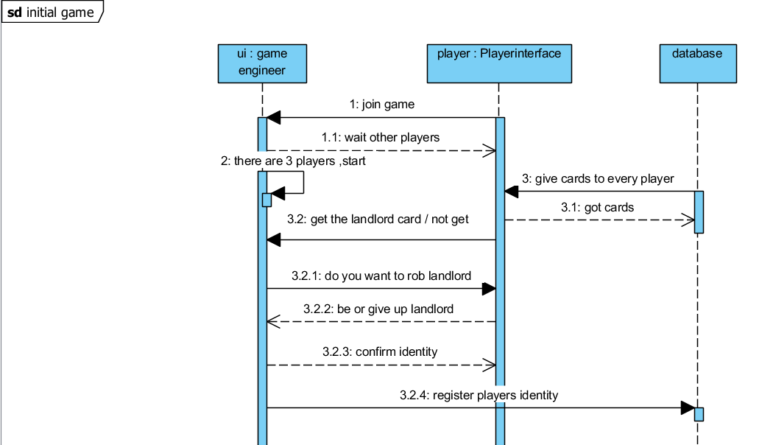

S1.1.2 Now we use remember players’ information so just need three players all press start

Player 1 is the beautiful girl

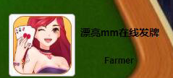

Player2 is rich woman

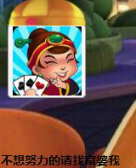

Player3 is rich lord who likes play boom show

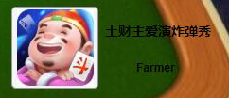

#### S1.2: rob lord

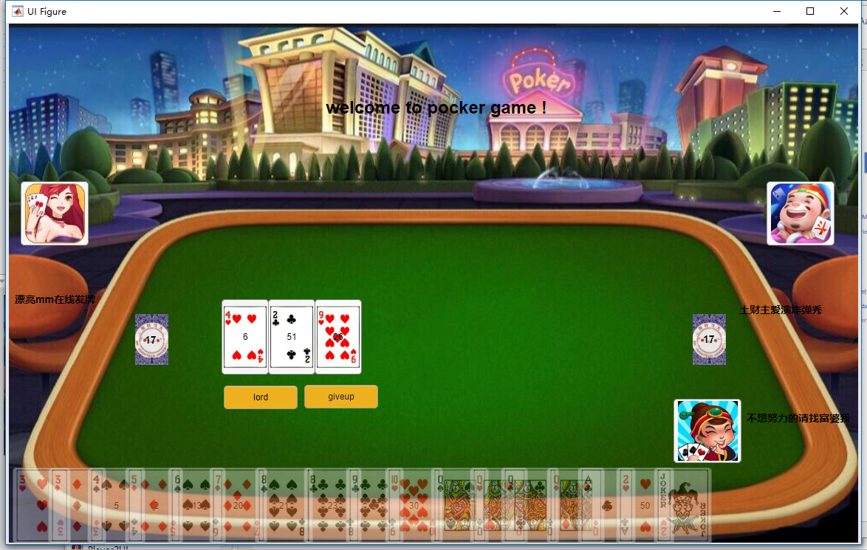

Roblist like [player1,player2,player3]If anyone choose give up, he leave the roblist. And if only one in the roblist(two give up), he become the lord. If anyone in the list rob lord for 2 times, he become the lord.So the one git dizhu card has preponderance.

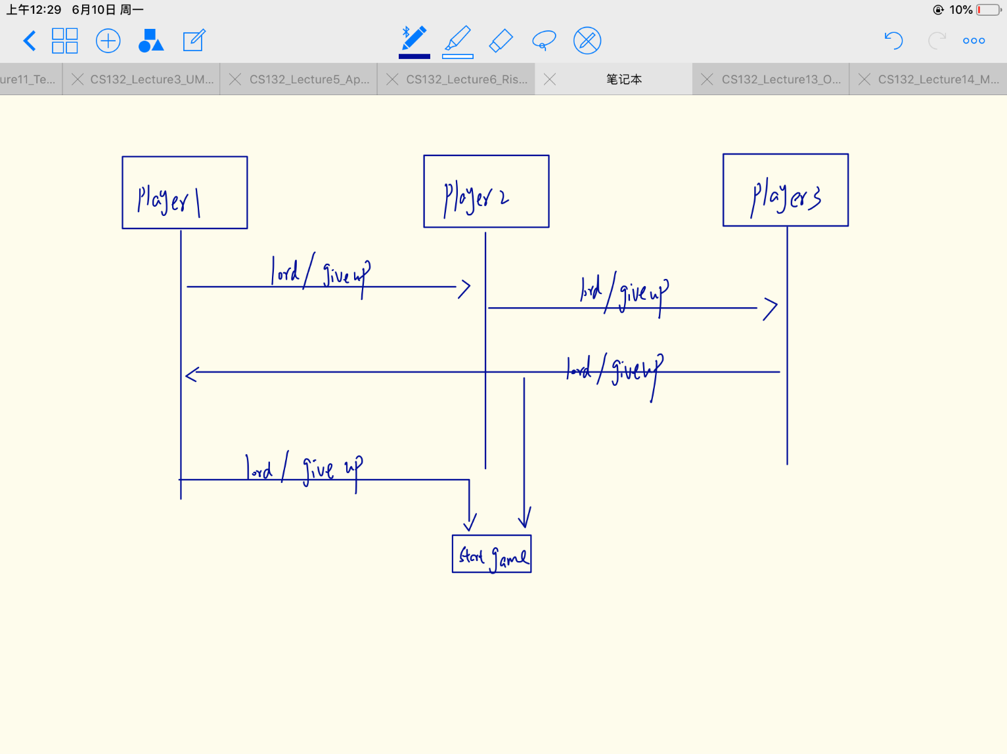

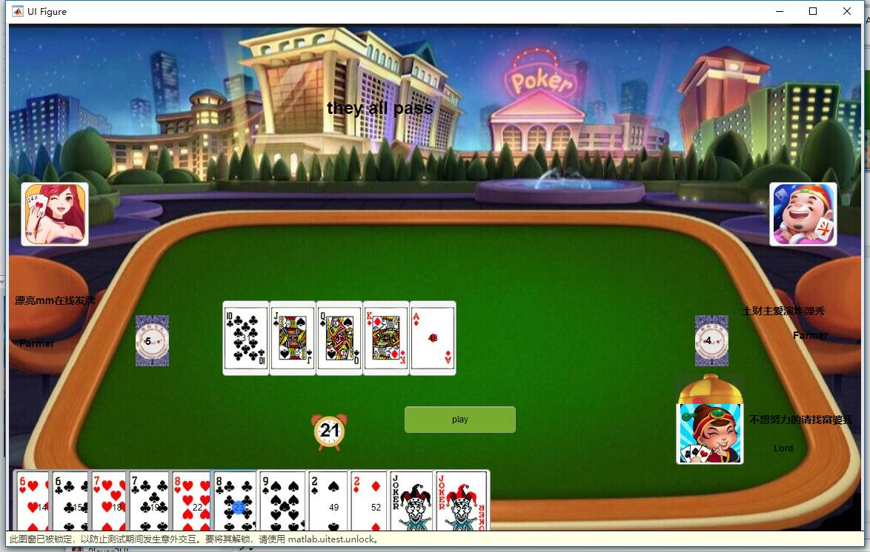

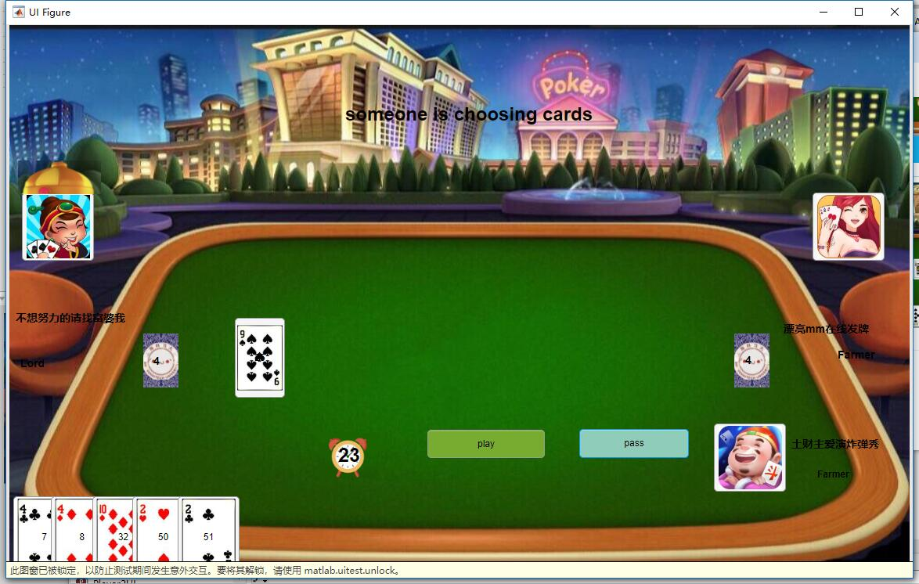 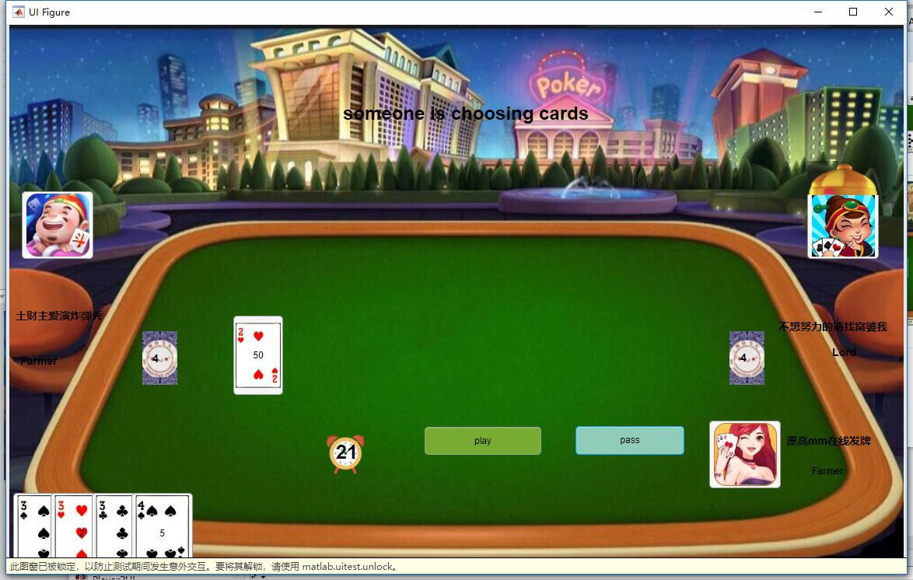

Lord will have a little hat on his head to show he/she is the lord

### S1.3 start to play the cards

Cards will be send out, lord has 20 cards , farmers has 17 cards

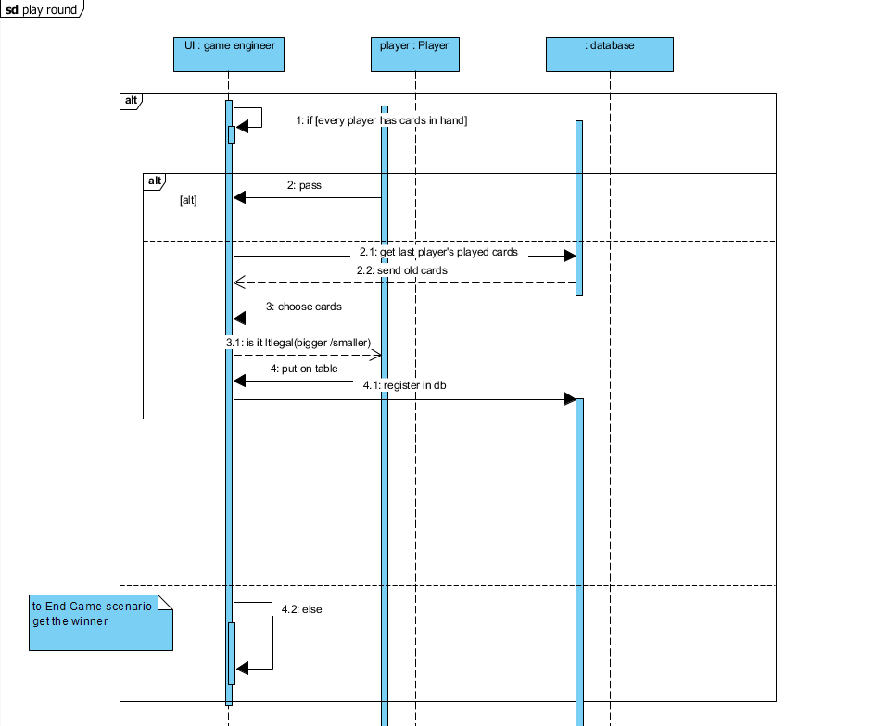

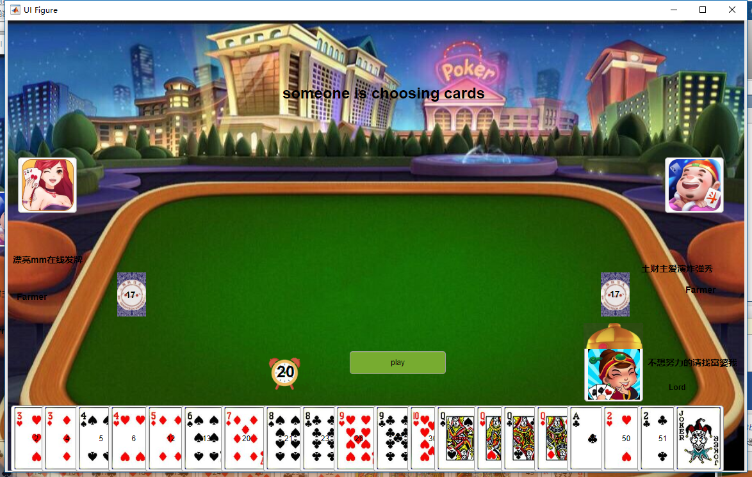

S1.3.1Everyone has 25 seconds to choose and play the cards, there is a little clock to tell you the time. If time is out pass his/her turn

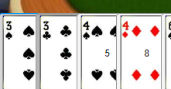

S1.3.2: When choose the cards, the cards will be grey

S1.3.3: The first player can not pass and then you can pass



S1.3.4: When two players pass, the has played cards stored change to []. So current player can play anything again just like first one to play the game and also his pass button will not be enable or visible.



S1.4 put all cards played out to 9 kinds

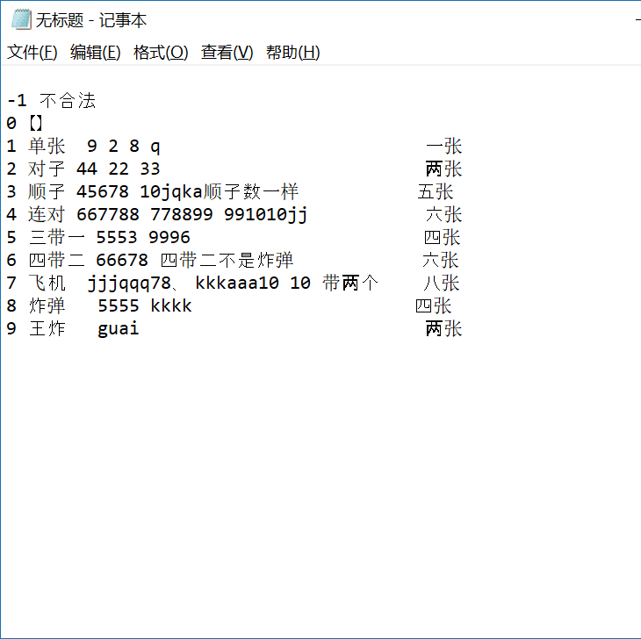

First judge how many cards it has. Second, judge witch kind its belong to.

1.4.1 Divide it to 10 kinds, if it’s illegal like 34, 333444 , it -1 kind

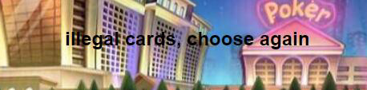

And you will see tip like this to mind you choose again

Do this judge to the cards on the table(the cards played by player before current player) & the cards played by current player. Then compare then boom(kind 8) and wangzha(kind 9) is stonger than other kind, others need to be the same kind and the card need to be bigger

S1.4.2 airplane wangzha boom have UI effect

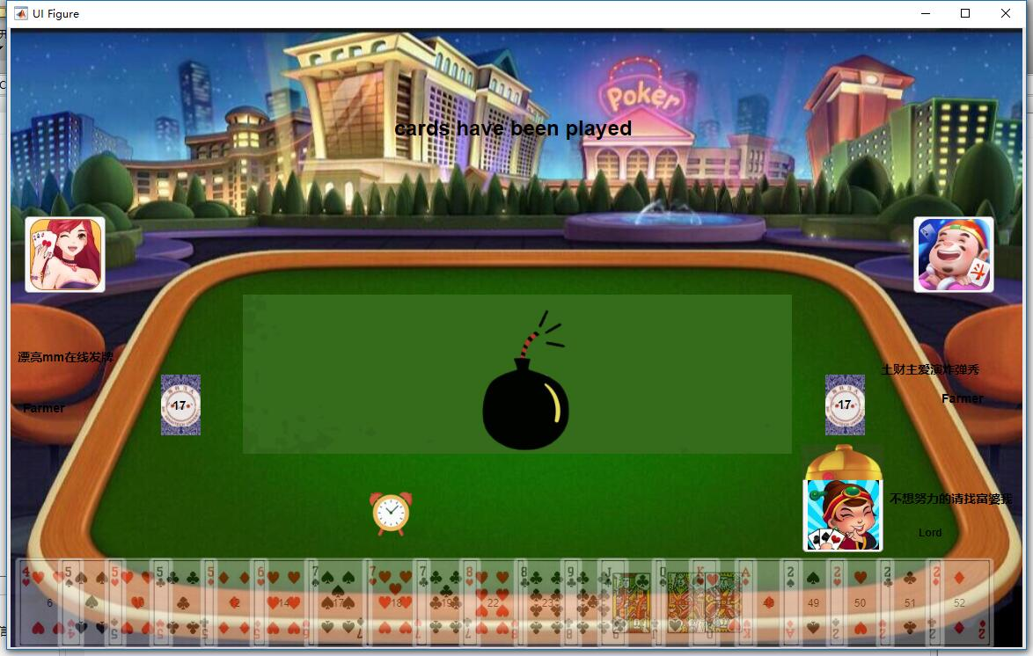

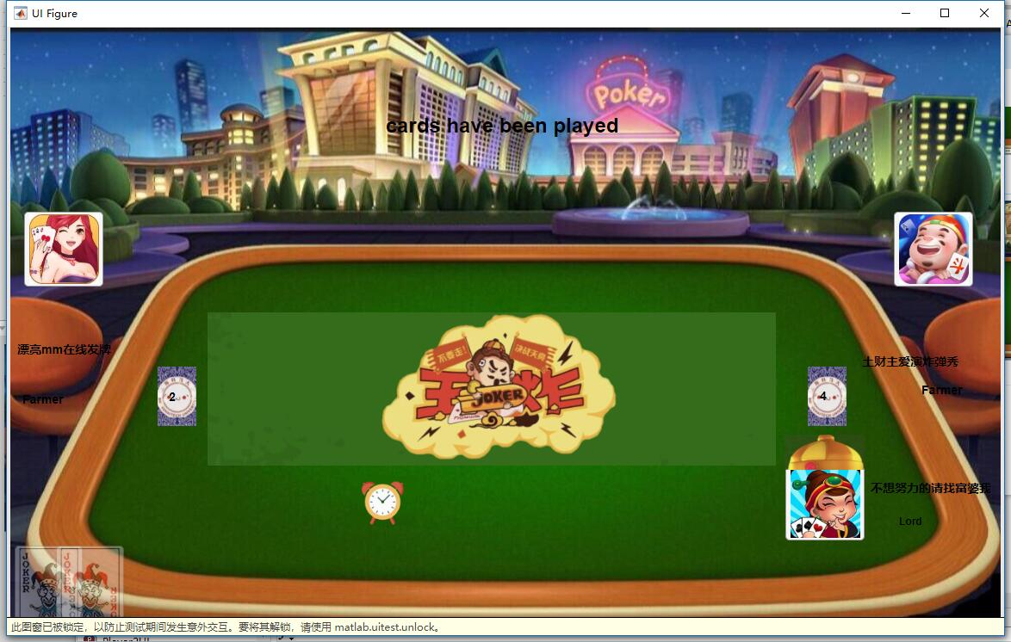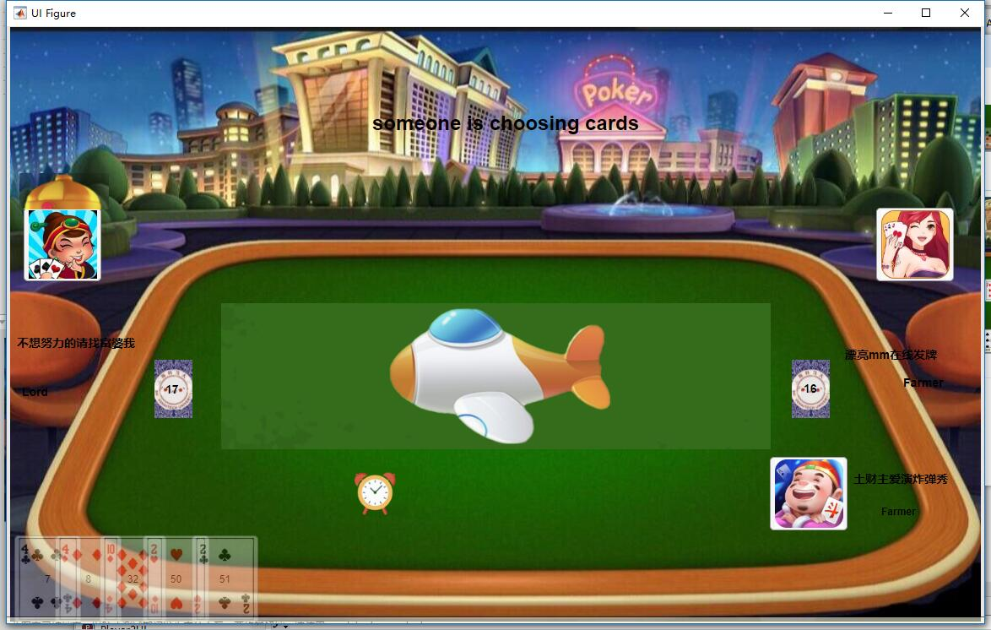

S1.5 anyone has cards less than 3, there will be an alarm

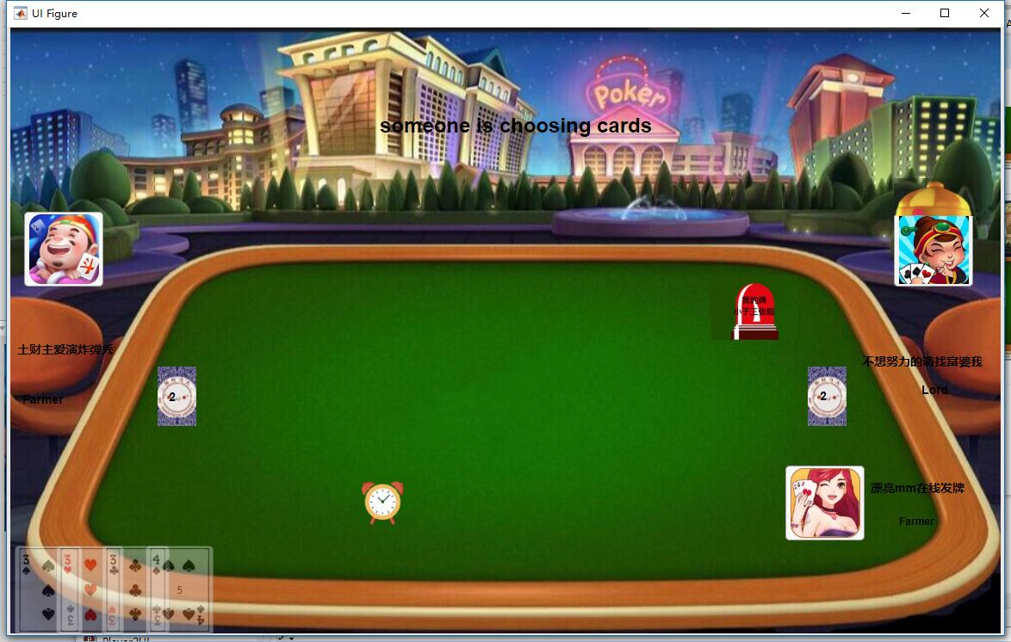

S1.6 lord or farmer win

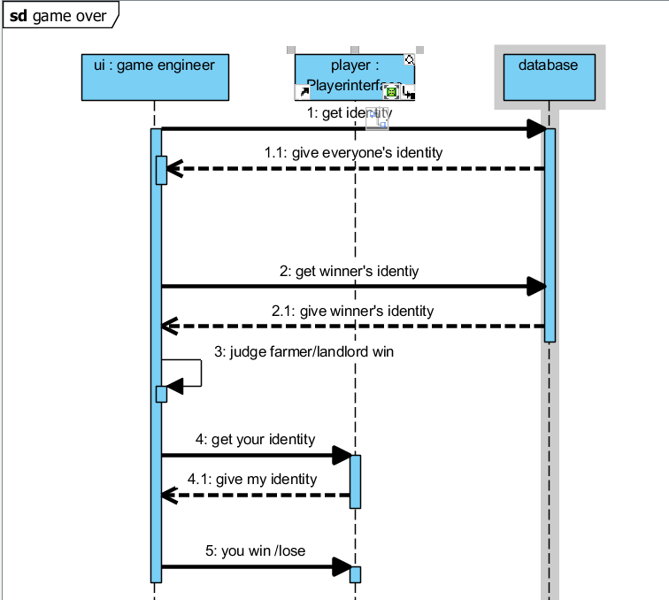

Every one play cards do one judge, if his cards in hand is empty

